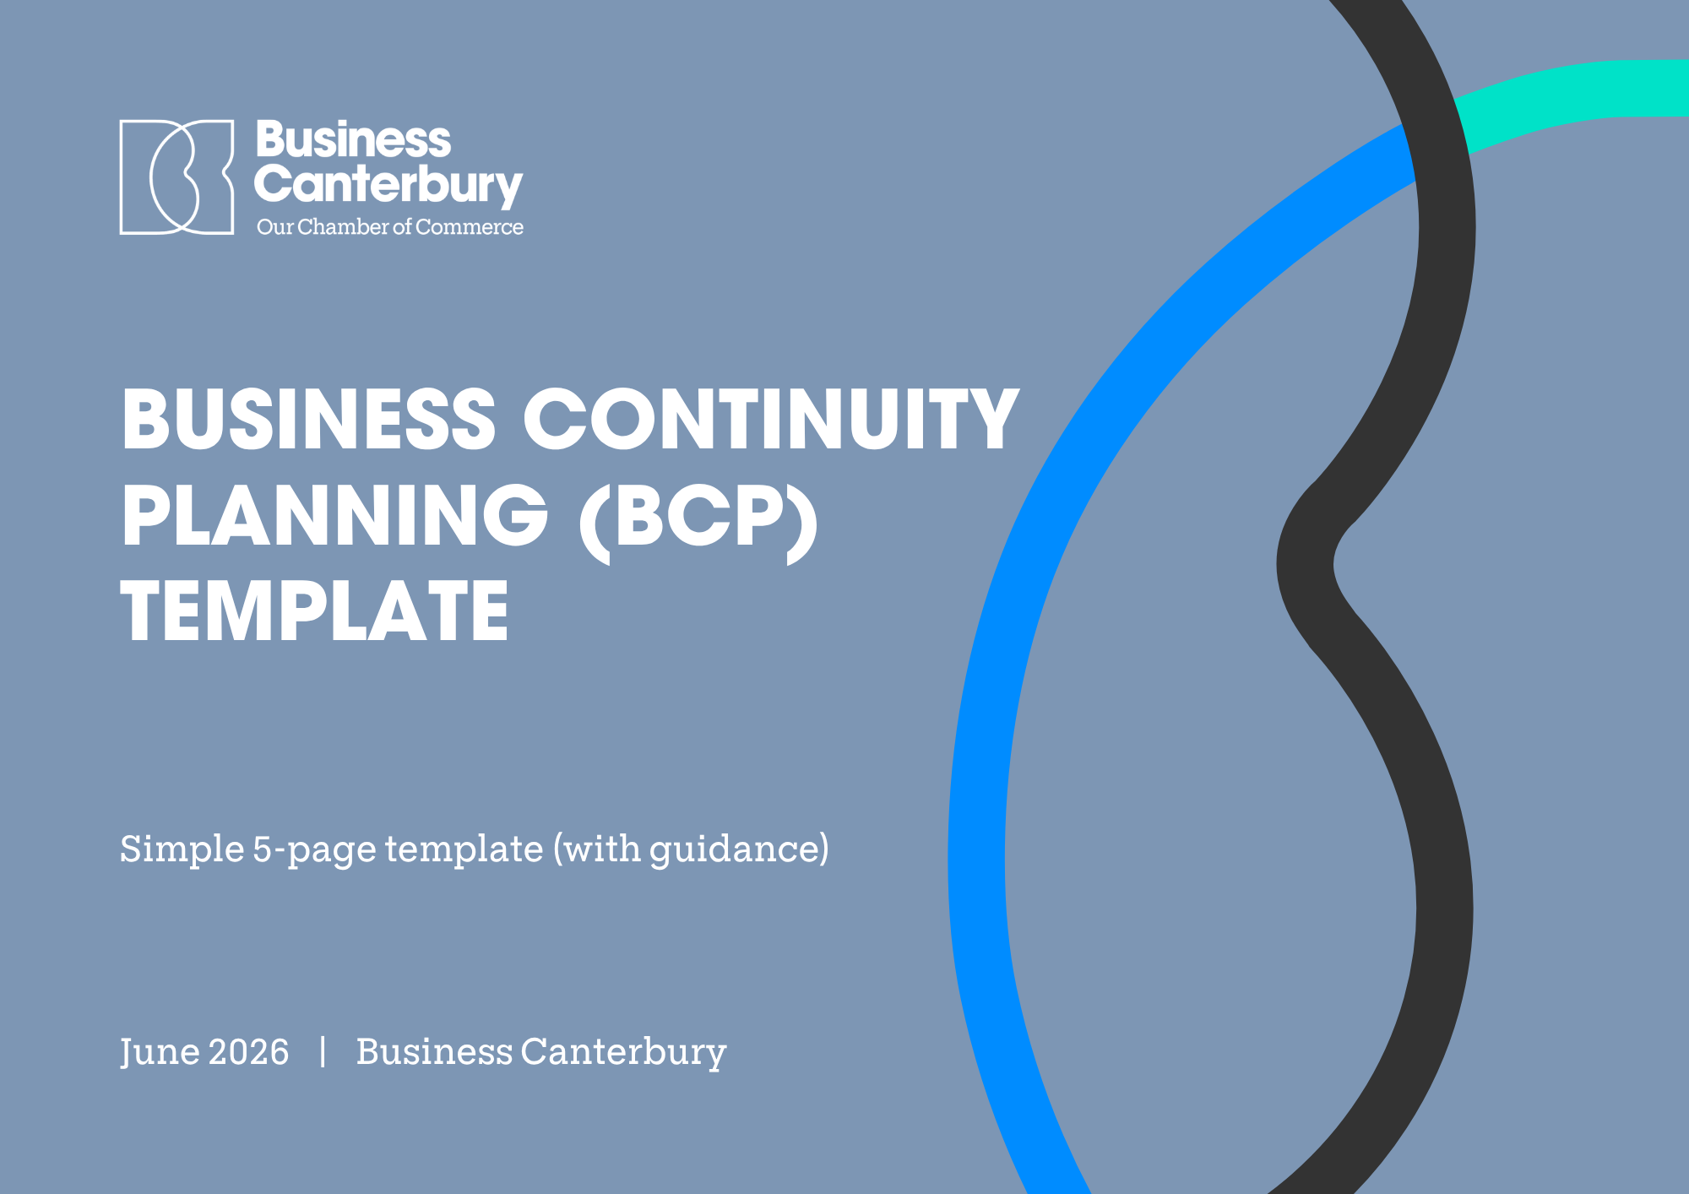

BUSINESS CONTINUITY PLAN (BCP)
Simple 5-page BCP template (with bracketed guidance in fields)
Field | Details | Owner / location | Last checked
Business / organisation | [Business name and legal entity] | [Owner] | [Date]
Sites, services or activities covered | [Sites, services, products or teams] | [Owner] | [Date]
Prepared by | [Plan owner / adviser] | [Owner] | [Date]
Plan owner / backup owner | [Plan owner] / [Backup owner] | [Contact details] | [Date]
Response lead / backup | [Response lead] / [Backup response lead] | [Contact details] | [Date]
Current approved copy | [Link / folder / system / physical location] | [Owner] | [Date]
Offline or offsite copy | [Emergency pack / printed copy / alternate site] | [Owner] | [Date]
Version / date / next review | [Version 1.0] / [Date] / [Date] | [Document control owner] | [Date]

Important use notes: This template should be completed with reference to the Business Continuity Planning Guide.
This is a simplified template for small businesses that need a simple, practical continuity plan. Replace bracketed guidance, remove rows that are not relevant, and review legal, health and safety, cyber/privacy, insurance, tax and sector-specific obligations with appropriate advisers. Keep one current approved copy and one offline or offsite copy.

Contents
This page uses an automatic table of contents. Refresh document fields after changes so headings and page numbers update.
Plan overview and control 2
1. Assess and prepare 3
2. Respond 5
3. Review and maintain 7

Incident quick reference

Need | Go to
Immediate safety or emergency response | Emergency procedures; 2. Respond - first-hour checklist
Activate the plan and assign lead roles | Plan overview and control; 2. Respond
Identify what must keep running and which functions are affected | 1. Assess and prepare - critical activities and simple recovery actions
Find key contacts and providers | 1. Assess and prepare - contacts and dependencies
Record decisions, messages, costs and evidence | 2. Respond - logs; 3. Review and maintain

Plan overview and control
Complete before a disruption. Keep this simple and practical so the plan can be used quickly by the owner, manager or response lead.

Scope and responsibilities

Item | Included in this plan | Owner / backup | Notes / location
Business scope | [Legal entity, trading name, sites and services covered] | [Owner / backup] | [Exclusions, if any]
Response lead | [Who decides whether to activate the plan] | [Primary / backup] | [Contact method]
Emergency response | [How this links to evacuation, safety or emergency procedures] | [Site / people lead] | [Procedure location]
Approved copy | [Where the live copy is stored] | [Plan owner] | [Offline copy location]

1 – 2. Assess and Prepare
List only the activities that matter most. Include the lead function or business area so responsibility is clear without creating a full function-impact matrix.

Critical activities and simple recovery actions
Priority / CP ID | Critical activity | Lead / supporting function(s) | Minimum service level | Main dependency | Simple recovery action | Owner
1 / CP1 | [e.g. customer orders / booked work] | [Operations; sales/customer service] | [Urgent jobs only] | [System / staff / supplier] | [Manual log, customer calls, reduced service] | [Name]
2 / CP2 | [e.g. payroll / payments] | [Finance; people] | [Meet statutory or critical deadlines] | [Bank / payroll access] | [Backup approver, manual schedule, adviser support] | [Name]
3 / CP3 | [e.g. customer service] | [Sales/customer service; technology] | [Respond to urgent enquiries] | [Phones / email / records] | [Use mobile, group inbox, priority contact list] | [Name]
4 / CP4 | [e.g. stock / delivery / site operations] | [Operations; supplier/logistics] | [Priority products or services only] | [Supplier / premises] | [Backup supplier, alternate site, reschedule] | [Name]

Key contacts, systems and providers
Type | Name / system / provider | What they support | Backup option | Contact / location
People / functions | [Owner, manager, payroll, banking approver, function leads] | [Critical roles, functions and decisions] | [Backup person or cross-trained cover] | [Phone / email]
Technology | [Accounting, payroll, email, job or customer system] | [Records and processing] | [Offline export / provider] | [Support contact]
Supplier / logistics | [Key supplier, courier, outsourced provider] | [Input, delivery or service] | [Alternate provider] | [Escalation contact]
Finance / insurance | [Bank, funder, broker, insurer, adviser] | [Cash, claims and obligations] | [Backup contact] | [Phone / email]

3. Respond
Use during a disruption or scenario test. Focus first on safety, facts, decisions, communications and practical actions.

Activation triggers and first actions
Trigger | Examples | First action | Decision owner
People safety risk | Injury, evacuation, welfare concern | Follow emergency procedures and account for people. | [Response / people lead]
Site unavailable | Premises unsafe, closed or inaccessible | Move to remote work, alternate site or temporary closure. | [Response / operations lead]
Critical system or data outage | Accounting, payroll, email, customer records, banking | Pause risky activity, contact provider, start manual workarounds. | [Technology / response lead]
Supplier, logistics or staffing issue | Key supplier, courier, owner or staff member unavailable | Prioritise critical work and activate backup people or providers. | [Operations lead]
Cash, legal, privacy or media risk | Revenue impact, breach, claim, regulator or public attention | Centralise decisions, evidence and communications; seek advice. | [Response lead]

First-hour checklist
Step | Immediate action | Owner | Completed / notes
1 | Confirm life safety, emergency services involvement and immediate hazards. | [People / site lead] | [ ]
2 | Open a decision log and record known facts, timing, source and first decisions. | [Response lead] | [ ]
3 | Confirm affected people, sites, functions, systems, suppliers, customers, data and cash flow. | [Response team] | [ ]
4 | Agree priorities, meeting rhythm, next update time and who approves messages. | [Response lead] | [ ]
5 | Start recovery actions for priority activities and preserve evidence. | [Process owners] | [ ]

Communication and evidence log

Date / time | Audience or evidence | Message / decision / evidence captured | Owner | Next action
[Date/time] | [Staff / customers / suppliers / bank / insurer] | [Message summary, decision, photo, log, cost, invoice or file link] | [Name] | [Due]
[Date/time] | [Audience / evidence] | [Summary or location] | [Name] | [Due]
[Date/time] | [Audience / evidence] | [Summary or location] | [Name] | [Due]

4. Review and maintain
Use after a disruption or test, and during routine reviews. Keep improvements practical and assign them to an owner and date.

Return-to-normal checklist
Checklist item | Evidence / decision required | Owner | Complete
Critical activities restored to acceptable or normal service levels. | [Owner confirmation / status report] | [Name] | [ ]
Manual records entered into systems and reconciled. | [Reconciliation and exceptions reviewed] | [Name] | [ ]
Staff, customer, supplier, bank, insurer and adviser updates issued if needed. | [Approved messages and recipients] | [Name] | [ ]
Costs, losses, decisions and claim evidence stored. | [Evidence folder updated] | [Name] | [ ]
Backlog, quality issues and wellbeing risks assigned to owners. | [Action plan] | [Name] | [ ]

Review and testing cycle
Timing | Action | Owner | Evidence / status
Quarterly | Check contacts, response roles, delegated authorities, critical suppliers and offline access. | [Plan owner] | [Updated copy]
Every 6-12 months | Review critical activities, lead/supporting functions, recovery actions, systems, suppliers, insurance and cash arrangements. | [Owner / manager] | [Updated version]
Annually | Run one simple scenario test, contact test or manual workaround drill. | [Response lead] | [Test record]
After disruption or material change | Record lessons, update actions and approve material changes. | [Plan owner] | [Action tracker]
Minimum readiness checklist
Readiness item | Minimum expectation | Status / notes
Ownership confirmed | Plan owner, backup owner and response lead are named. | [ ]
Critical activities prioritised | The top activities, functions and simple workarounds are documented. | [ ]
Contacts available offline | Key people, providers, bank, insurer and adviser contacts are accessible. | [ ]
Evidence process ready | Decision, cost, loss and communication records have a known storage location. | [ ]
Review date set | Next review and testing date are agreed. | [ ]

Notes:


