Tips for sleeping well
Sleep is vital for your body to recover physically and mentally. If you get enough sleep, you think better, plan better and get more done. You feel happier too. People who don’t get enough sleep feel lonelier – and those around them feel lonelier too, even if they themselves get enough sleep.
Enough sleep for most people is about eight hours: about nine in winter and seven in summer. But if you can’t fall asleep or stay asleep, how do you get enough sleep? See if these tips help.


Going about your day
What you do during the day affects sleep.

Get some exercise
Exercise helps you fall asleep faster and sleep better. Choose an exercise you enjoy and do it for 20 minutes, two or three times a week.
But don’t exercise hard within five hours of bedtime because that increases your body temperature. An after-dinner stroll is OK.

Get half an hour of sunlight a day
Get your sunlight however it suits you, perhaps going for a walk at lunchtime, or gardening after work. Sunlight helps your body produce melatonin. Melatonin doesn’t help you fall asleep, but it helps you sleep well and wake up refreshed.

Avoid caffeinated drinks late in the day
Avoid caffeinated drinks from mid- to late afternoon, because your body takes 8 to 13 hours to get rid of caffeine. Coffee and tea are big sources of caffeine, but caffeine hides in other drinks too, like green tea and energy drinks.

Avoid alcohol late at night
Drinking late will wake you up in the middle of the night when your body has turned the alcohol into sugar. Your body tries to process the sugar by being active, which wakes you up.

Avoid using your bed for other activities
Keep your bed only for sex and sleep, otherwise your body associates being in bed with other activities such as work or watching TV. This makes it harder to fall asleep.

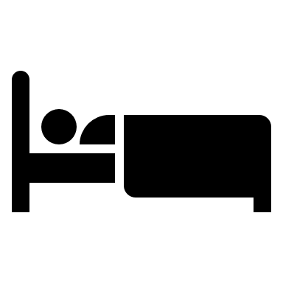
Preparing for sleep
How you spend your evening matters. A regular bedtime is important, but these tips might help too.

Switch off before bedtime
Stop work an hour and a half before bedtime to give your brain a break. Working late keeps your brain active and that interferes with sleep.
Turn off devices an hour and a half before bedtime too. Devices give off blue light, which stops your body producing melatonin.

Deal with your thoughts before going to bed
If you tend to lie awake thinking or worrying, try to deal with your thoughts before bedtime. For example, write down your to-do list for the next day. Or write down three things you’re grateful for, to help you focus on what’s positive as you fall asleep.

Keep your room cool, dark and quiet
Make sure your room and your body aren’t too hot. Your body prepares for sleep by cooling down about two hours before you normally go to bed, and this makes you feel tired. On a hot night, having a cold shower before you go to bed might help.
Darken your room. Draw your curtains and put devices away. Eyeshades might help if streetlights shine through your curtains.
Reduce noise as much as possible. If you need to, consider using earplugs or an app with relaxing music or sounds of nature.

Relax your body
As you lie in bed, close your eyes and relax your whole body progressively. Start by consciously relaxing each group of muscles in your face. Relax your neck and shoulders next. Keep relaxing muscles until you get to your feet.

Get some exercise
Exercise helps you fall asleep faster and sleep better. Choose an exercise you enjoy and do it for 20 minutes, two or three times a week.
But don’t exercise hard within five hours of bedtime because that increases your body temperature. An after-dinner stroll is OK.


Getting medical help if needed

Our general advice will work for most people, whatever stage of life you’re at. But if you’ve tried our tips and still can’t sleep, consider seeing a doctor or health professional in case you have a health condition that stops you from sleeping.

